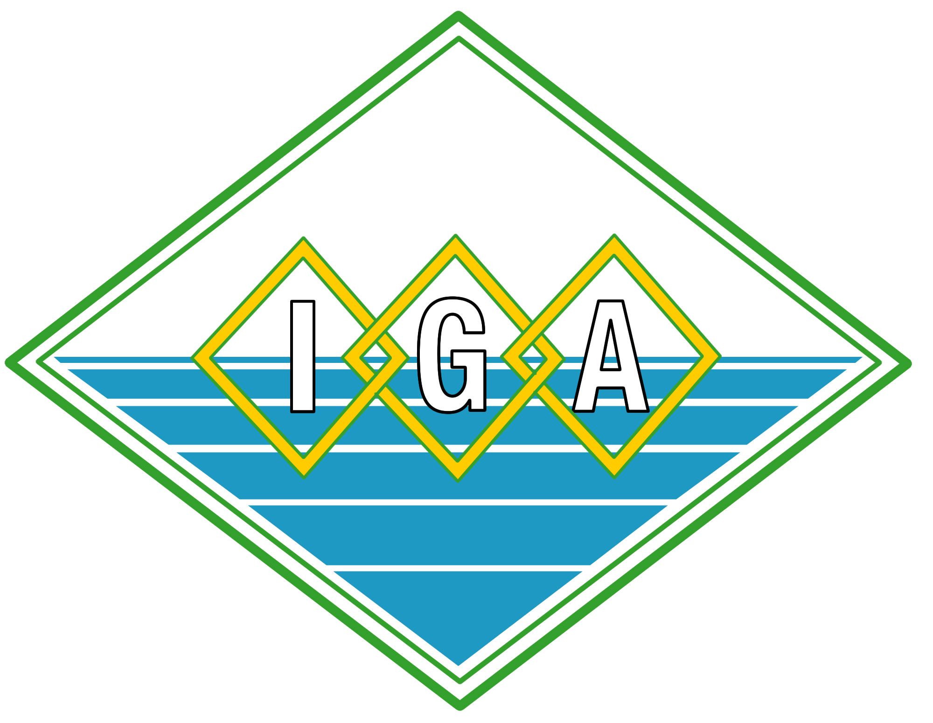

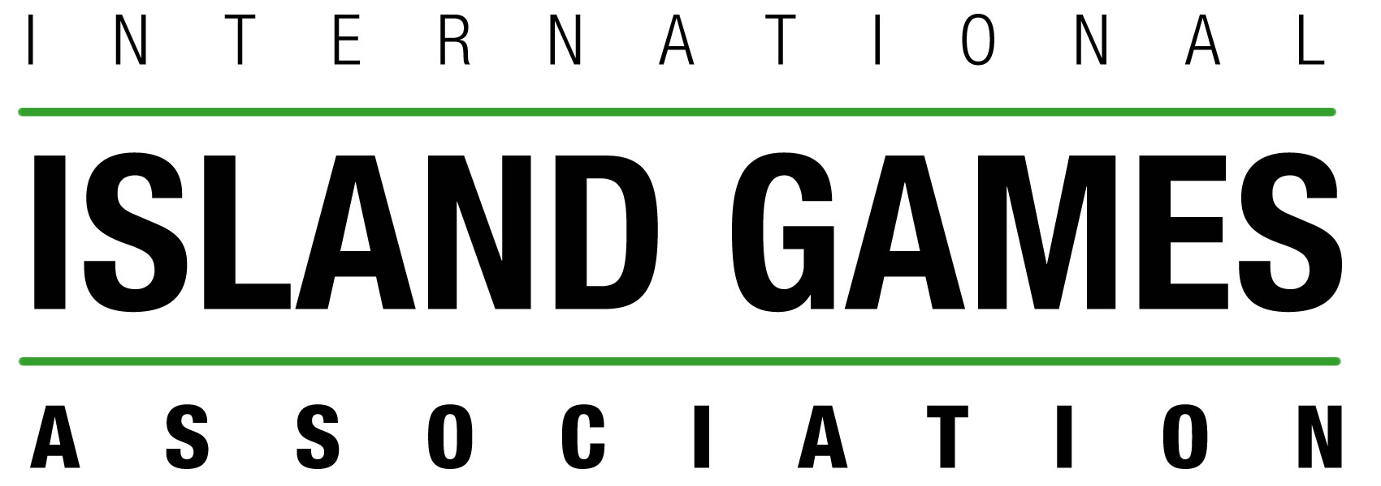

The NatWest Sports Development Scheme

Application for Grant Payment

Application number

Name of Member Island

Sport(s) supported

Please give a brief report including all relevant details of the scheme including information on the date/s and duration of the scheme/trips, the age range and number of participants that benefitted from the scheme. The report should outline how the scheme may have increased participation levels and standards of performance in the sport(s). Also include copies of any relevant competition results, certificates issued or photographs taken together with media coverage. Where possible, NatWest recognition/branding of the event would be appreciated.

Summary of actual costs for the scheme:

Travel: £

Accommodation: £

Others: £

Amount of NatWest Grant sanctioned for payment £

Please include copies of all relevant invoices/receipts, Bank account details including the IBAN name and address of Bank, account name and number.

To be signed on behalf of the Claimant:

Signature …………………………………

Position held within the Sport ………………………………………………..

Date of Claim ……………………………………..

PLEASE NOTE: Claims must be submitted to the IIGA Office within 3 months of the final event of the grant scheme taking place otherwise such claims may be forfeited.

This grant claim should be emailed to iga@manx.net or posted to:

International Island Games Association
Goldie House 2nd Floor, 1 - 4 Goldie Terrace,
Douglas, Isle of Man IM 1EB

Official use only

Amount of grant approved and date ………………………………

Signed ………………………….

